ASSIGNMENT 3

Ria Mittal
322010
T.E. B - B1

***Design at least 10 SQL queries for suitable database application using SQL DML statements: Insert, Select, Update, Delete with operators, functions, and set operator ***

mysql> create database data;
Query OK, 1 row affected (0.00 sec)

mysql> use data;
Database changed
mysql> create table user(name varchar(50),email varchar(50),address varchar(50),age integer);
Query OK, 0 rows affected (0.28 sec)

INSERT:
mysql> insert into user values("ria","mittalria0809@gmail.com","pune",20);
Query OK, 1 row affected (0.05 sec)

mysql> insert into user values("rohit","rohitpingulkar123@gmail.com","mumbai",19);
Query OK, 1 row affected (0.06 sec)

mysql> insert into user values("honey","talrejahoney8@gmail.com","bhusawal",19);
Query OK, 1 row affected (0.05 sec)

mysql> insert into user values("pranav","pranavshirude.ps@gmail.com","jalgaon",20);
Query OK, 1 row affected (0.05 sec)

mysql> insert into user values("ankita","ankitanarkhede3@gmail.com","dapoli",20);
Query OK, 1 row affected (0.04 sec)

mysql> insert into user values("shrirang","shrirangmhalgi9@gmail.com","pune",20);
Query OK, 1 row affected (0.04 sec)

mysql> insert into user values("shashidhar","shashidharnagaral5@gmail.com","sangli",20);
Query OK, 1 row affected (0.05 sec)

mysql> insert into user values("rakhi","rakhimarathe24@gmail.com","boisar",20);
Query OK, 1 row affected (0.05 sec)

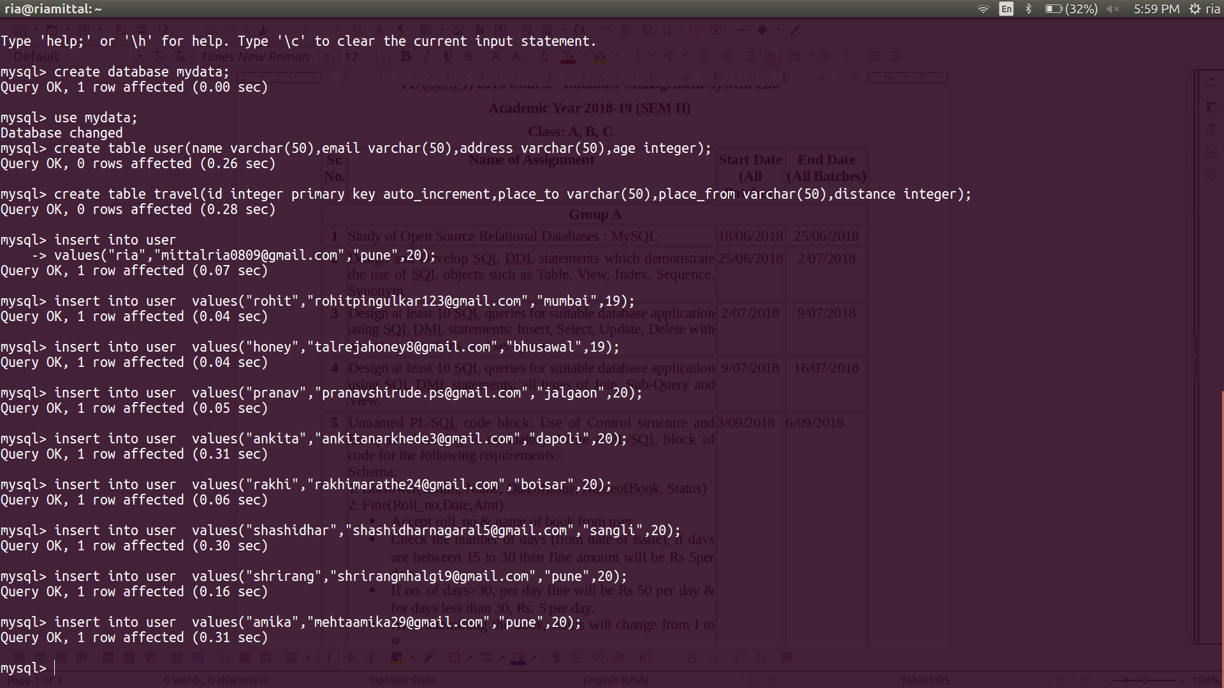

SELECT:

mysql> select
-> * from user;
+------------+------------------------------+----------+------+
| name | email | address | age |
+------------+------------------------------+----------+------+
| ria | mittalria0809@gmail.com | pune | 20 |
| rohit | rohitpingulkar123@gmail.com | mumbai | 19 |
| honey | talrejahoney8@gmail.com | bhusawal | 19 |
| pranav | pranavshirude.ps@gmail.com | jalgaon | 20 |
| ankita | ankitanarkhede3@gmail.com | dapoli | 20 |
| shrirang | shrirangmhalgi9@gmail.com | pune | 20 |
| shashidhar | shashidharnagaral5@gmail.com | sangli | 20 |
| rakhi | rakhimarathe24@gmail.com | boisar | 20 |
+------------+------------------------------+----------+------+
8 rows in set (0.00 sec)

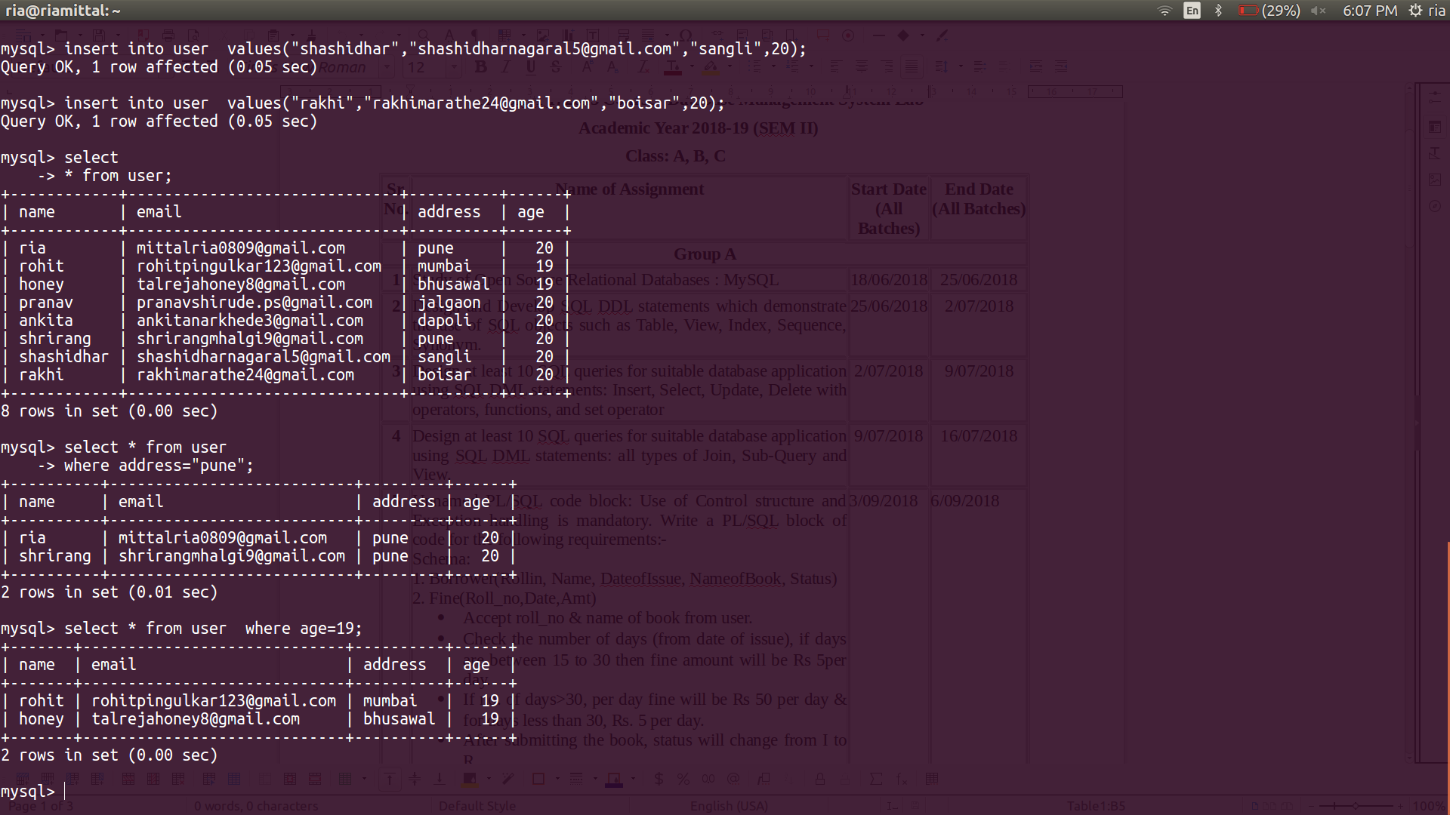
SELECT with WHERE clause:
mysql> select * from user
-> where address="pune";
+----------+---------------------------+---------+------+
| name | email | address | age |
+----------+---------------------------+---------+------+
| ria | mittalria0809@gmail.com | pune | 20 |
| shrirang | shrirangmhalgi9@gmail.com | pune | 20 |
+----------+---------------------------+---------+------+
2 rows in set (0.01 sec)

mysql> select * from user where age=19;
+-------+-----------------------------+----------+------+
| name | email | address | age |
+-------+-----------------------------+----------+------+
| rohit | rohitpingulkar123@gmail.com | mumbai | 19 |
| honey | talrejahoney8@gmail.com | bhusawal | 19 |
+-------+-----------------------------+----------+------+
2 rows in set (0.00 sec)

mysql> insert into user values("amika","amikamehta@gmail.com","pune",19);
Query OK, 1 row affected (0.31 sec)

mysql> insert into user values("new user","newuser1234@viit.ac.in","pune",19);
Query OK, 1 row affected (0.05 sec)

mysql> select * from user;
+------------+------------------------------+----------+------+
| name | email | address | age |
+------------+------------------------------+----------+------+
| ria | mittalria0809@gmail.com | pune | 20 |
| rohit | rohitpingulkar123@gmail.com | mumbai | 19 |
| honey | talrejahoney8@gmail.com | bhusawal | 19 |
| pranav | pranavshirude.ps@gmail.com | jalgaon | 20 |
| ankita | ankitanarkhede3@gmail.com | dapoli | 20 |
| shrirang | shrirangmhalgi9@gmail.com | pune | 20 |
| shashidhar | shashidharnagaral5@gmail.com | sangli | 20 |
| rakhi | rakhimarathe24@gmail.com | boisar | 20 |
| amika | amikamehta@gmail.com | pune | 19 |
| new user | newuser1234@viit.ac.in | pune | 19 |
+------------+------------------------------+----------+------+
10 rows in set (0.00 sec)

UPDATE:
mysql> update user set age=20 where name="new user";
Query OK, 1 row affected (0.06 sec)
Rows matched: 1 Changed: 1 Warnings: 0

mysql> update user set address="PUNE" where address="pune";
Query OK, 4 rows affected (0.04 sec)
Rows matched: 4 Changed: 4 Warnings: 0

mysql> update user set address="MUMBAI" where address="mumbai";
Query OK, 1 row affected (0.04 sec)
Rows matched: 1 Changed: 1 Warnings: 0

mysql> select * from user;
+------------+------------------------------+----------+------+
| name | email | address | age |
+------------+------------------------------+----------+------+
| ria | mittalria0809@gmail.com | PUNE | 20 |
| rohit | rohitpingulkar123@gmail.com | MUMBAI | 19 |
| honey | talrejahoney8@gmail.com | bhusawal | 19 |
| pranav | pranavshirude.ps@gmail.com | jalgaon | 20 |
| ankita | ankitanarkhede3@gmail.com | dapoli | 20 |
| shrirang | shrirangmhalgi9@gmail.com | PUNE | 20 |
| shashidhar | shashidharnagaral5@gmail.com | sangli | 20 |
| rakhi | rakhimarathe24@gmail.com | boisar | 20 |
| amika | amikamehta@gmail.com | PUNE | 19 |
| new user | newuser1234@viit.ac.in | PUNE | 20 |
+------------+------------------------------+----------+------+
10 rows in set (0.00 sec)
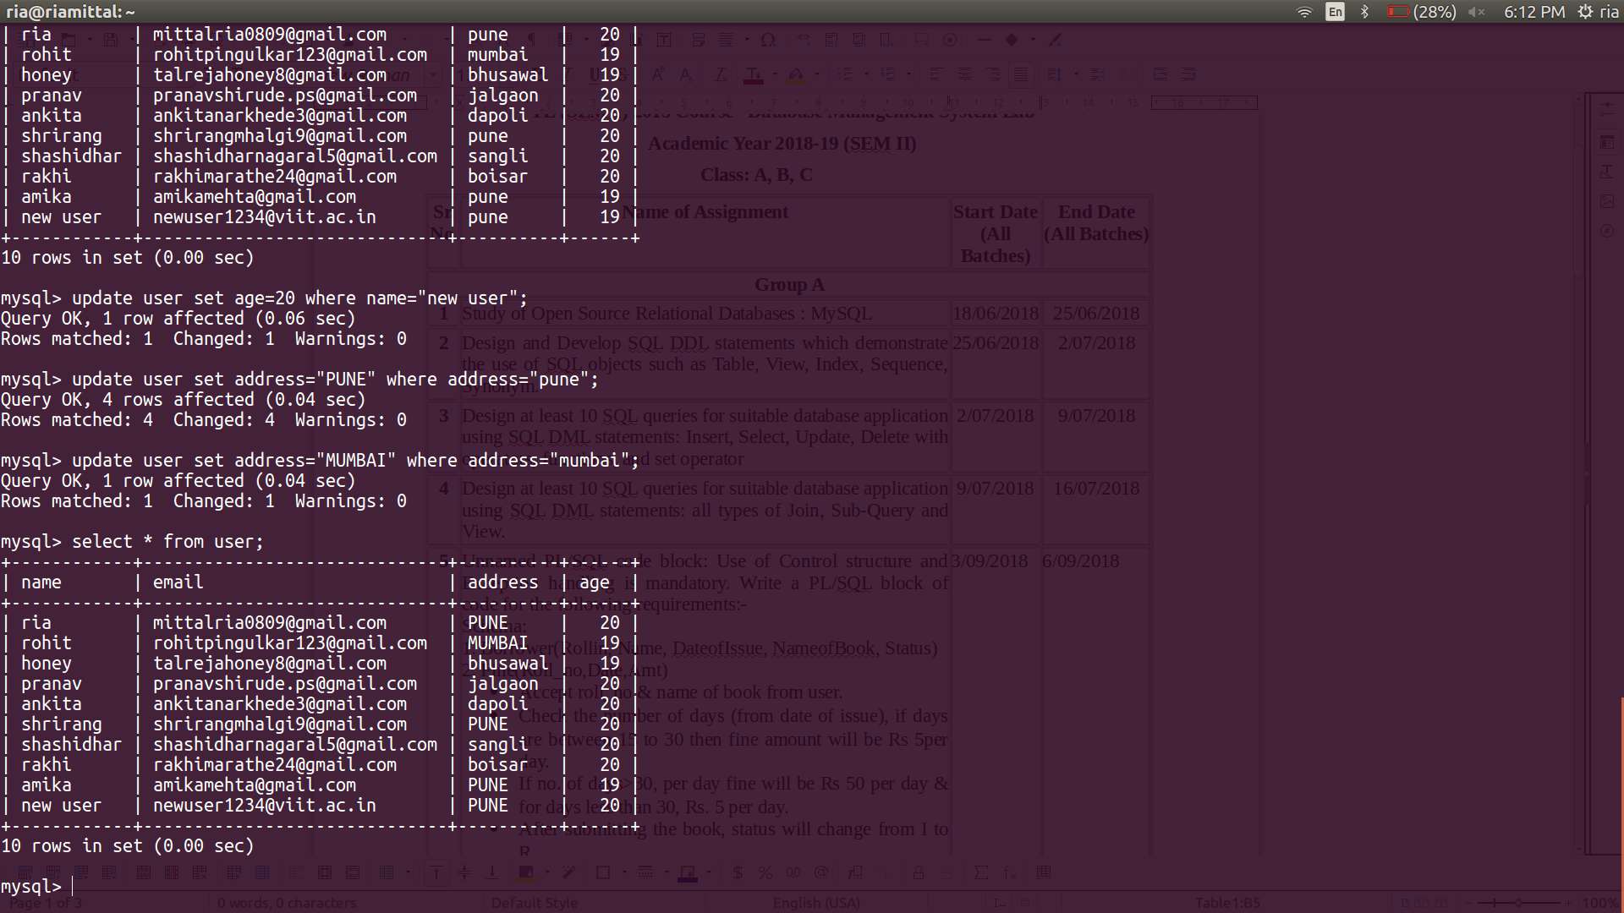
mysql> select * from user order by age;
+------------+------------------------------+----------+------+
| name | email | address | age |
+------------+------------------------------+----------+------+
| rohit | rohitpingulkar123@gmail.com | MUMBAI | 19 |
| honey | talrejahoney8@gmail.com | bhusawal | 19 |
| ria | mittalria0809@gmail.com | PUNE | 20 |
| pranav | pranavshirude.ps@gmail.com | jalgaon | 20 |
| ankita | ankitanarkhede3@gmail.com | dapoli | 20 |
| shrirang | shrirangmhalgi9@gmail.com | PUNE | 20 |
| shashidhar | shashidharnagaral5@gmail.com | sangli | 20 |
| rakhi | rakhimarathe24@gmail.com | boisar | 20 |
+------------+------------------------------+----------+------+
8 rows in set (0.00 sec)

SELECT with ORDER BY clause:
mysql> select * from people order by age;
+----------+-----------------------------+---------+------+
| name | email | address | age |
+----------+-----------------------------+---------+------+
| niomi | niomi@gmail.com | kolkata | 12 |
| akriti | akriti@gmail.com | pune | 19 |
| aarush | aarush@gmail.com | pune | 19 |
| rohit | rohitpingulkar123@gmail.com | MUMBAI | 19 |
| niharika | niharika@gmail.com | pune | 20 |
| ria | mittalria0809@gmail.com | PUNE | 20 |
| ankita | ankitanarkhede3@gmail.com | dapoli | 20 |
| abc | abc@gmail.com | delhi | 21 |
| advit | advit@gmail.com | pune | 22 |
| pqr | pqr@gmail.com | kolkata | 24 |
+----------+-----------------------------+---------+------+
10 rows in set (0.00 sec)

mysql> select * from user order by name;
+------------+------------------------------+----------+------+
| name | email | address | age |
+------------+------------------------------+----------+------+
| ankita | ankitanarkhede3@gmail.com | dapoli | 20 |
| honey | talrejahoney8@gmail.com | bhusawal | 19 |
| pranav | pranavshirude.ps@gmail.com | jalgaon | 20 |
| rakhi | rakhimarathe24@gmail.com | boisar | 20 |
| ria | mittalria0809@gmail.com | PUNE | 20 |
| rohit | rohitpingulkar123@gmail.com | MUMBAI | 19 |
| shashidhar | shashidharnagaral5@gmail.com | sangli | 20 |
| shrirang | shrirangmhalgi9@gmail.com | PUNE | 20 |
+------------+------------------------------+----------+------+
8 rows in set (0.00 sec)

mysql> select * from people order by name;
+----------+-----------------------------+---------+------+
| name | email | address | age |
+----------+-----------------------------+---------+------+
| aarush | aarush@gmail.com | pune | 19 |
| abc | abc@gmail.com | delhi | 21 |
| advit | advit@gmail.com | pune | 22 |
| akriti | akriti@gmail.com | pune | 19 |
| ankita | ankitanarkhede3@gmail.com | dapoli | 20 |
| niharika | niharika@gmail.com | pune | 20 |
| niomi | niomi@gmail.com | kolkata | 12 |
| pqr | pqr@gmail.com | kolkata | 24 |
| ria | mittalria0809@gmail.com | PUNE | 20 |
| rohit | rohitpingulkar123@gmail.com | MUMBAI | 19 |
+----------+-----------------------------+---------+------+
10 rows in set (0.00 sec)

DELETE:

mysql> delete from user where name="amika";
Query OK, 1 row affected (0.05 sec)

mysql> delete from user where name="new user";
Query OK, 1 row affected (0.05 sec)

mysql> select * from user
-> ;
+------------+------------------------------+----------+------+
| name | email | address | age |
+------------+------------------------------+----------+------+
| ria | mittalria0809@gmail.com | PUNE | 20 |
| rohit | rohitpingulkar123@gmail.com | MUMBAI | 19 |
| honey | talrejahoney8@gmail.com | bhusawal | 19 |
| pranav | pranavshirude.ps@gmail.com | jalgaon | 20 |
| ankita | ankitanarkhede3@gmail.com | dapoli | 20 |
| shrirang | shrirangmhalgi9@gmail.com | PUNE | 20 |
| shashidhar | shashidharnagaral5@gmail.com | sangli | 20 |
| rakhi | rakhimarathe24@gmail.com | boisar | 20 |
+------------+------------------------------+----------+------+
8 rows in set (0.00 sec)
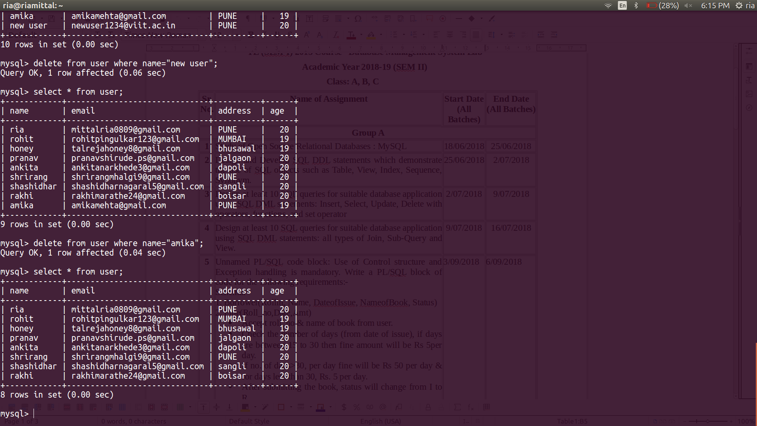

UNION :

mysql> select * from user
-> union
-> select * from people;
+------------+------------------------------+----------+------+
| name | email | address | age |
+------------+------------------------------+----------+------+
| ria | mittalria0809@gmail.com | PUNE | 20 |
| rohit | rohitpingulkar123@gmail.com | MUMBAI | 19 |
| honey | talrejahoney8@gmail.com | bhusawal | 19 |
| pranav | pranavshirude.ps@gmail.com | jalgaon | 20 |
| ankita | ankitanarkhede3@gmail.com | dapoli | 20 |
| shrirang | shrirangmhalgi9@gmail.com | PUNE | 20 |
| shashidhar | shashidharnagaral5@gmail.com | sangli | 20 |
| rakhi | rakhimarathe24@gmail.com | boisar | 20 |
| abc | abc@gmail.com | delhi | 21 |
| pqr | pqr@gmail.com | kolkata | 24 |
| niomi | niomi@gmail.com | kolkata | 12 |
| akriti | akriti@gmail.com | pune | 19 |
| advit | advit@gmail.com | pune | 22 |
| aarush | aarush@gmail.com | pune | 19 |
| niharika | niharika@gmail.com | pune | 20 |
+------------+------------------------------+----------+------+
15 rows in set (0.00 sec)
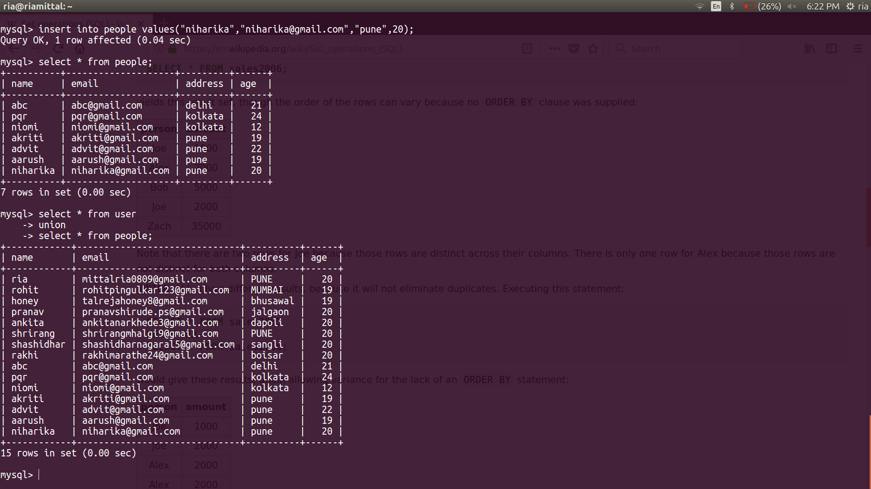
mysql> select * from user union all select * from people;
+------------+------------------------------+----------+------+
| name | email | address | age |
+------------+------------------------------+----------+------+
| ria | mittalria0809@gmail.com | PUNE | 20 |
| rohit | rohitpingulkar123@gmail.com | MUMBAI | 19 |
| honey | talrejahoney8@gmail.com | bhusawal | 19 |
| pranav | pranavshirude.ps@gmail.com | jalgaon | 20 |
| ankita | ankitanarkhede3@gmail.com | dapoli | 20 |
| shrirang | shrirangmhalgi9@gmail.com | PUNE | 20 |
| shashidhar | shashidharnagaral5@gmail.com | sangli | 20 |
| rakhi | rakhimarathe24@gmail.com | boisar | 20 |
| abc | abc@gmail.com | delhi | 21 |
| pqr | pqr@gmail.com | kolkata | 24 |
| niomi | niomi@gmail.com | kolkata | 12 |
| akriti | akriti@gmail.com | pune | 19 |
| advit | advit@gmail.com | pune | 22 |
| aarush | aarush@gmail.com | pune | 19 |
| niharika | niharika@gmail.com | pune | 20 |
| rohit | rohitpingulkar123@gmail.com | MUMBAI | 19 |
| ria | mittalria0809@gmail.com | PUNE | 20 |
| ankita | ankitanarkhede3@gmail.com | dapoli | 20 |
+------------+------------------------------+----------+------+
18 rows in set (0.00 sec)
